Earpiece Design
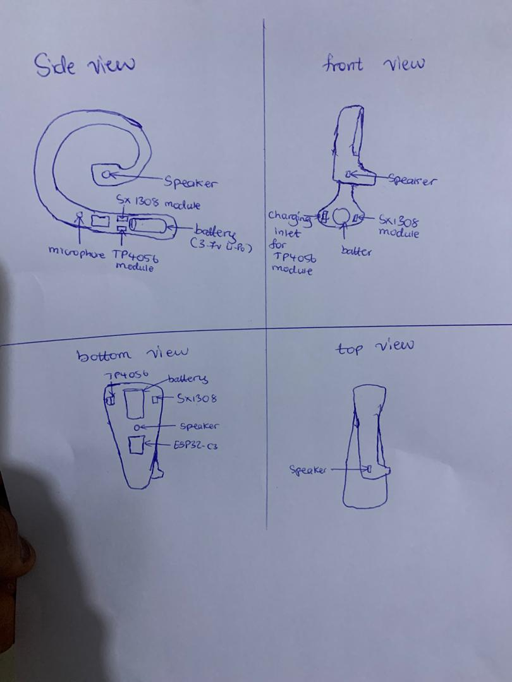
Inspiration
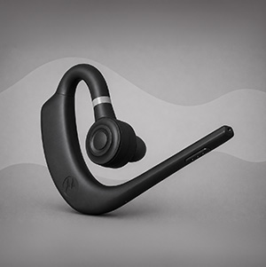


Reasoning for design choice
- The base was made large in order to house the 3.7v Li-Po battery, the TP4056 module ( this enables usb recharging of the battery ), the ESP32-C3 module, the SX1308 module ( this amplifies the battery output to power the ESP32 ) and the speaker module
- The circular shape of the earpiece was to ensure the earpiece hangs and is supported by the users ear ( not to a point of discomfort )
- The microphone is to be placed at the base to enhance audio perception when the wearer speaks

